

**Key:**

Main Tramper routes

Minor paths (safe but more challenging)

Steep gradient – reduce speed to minimum before descending

Take particular care in these areas

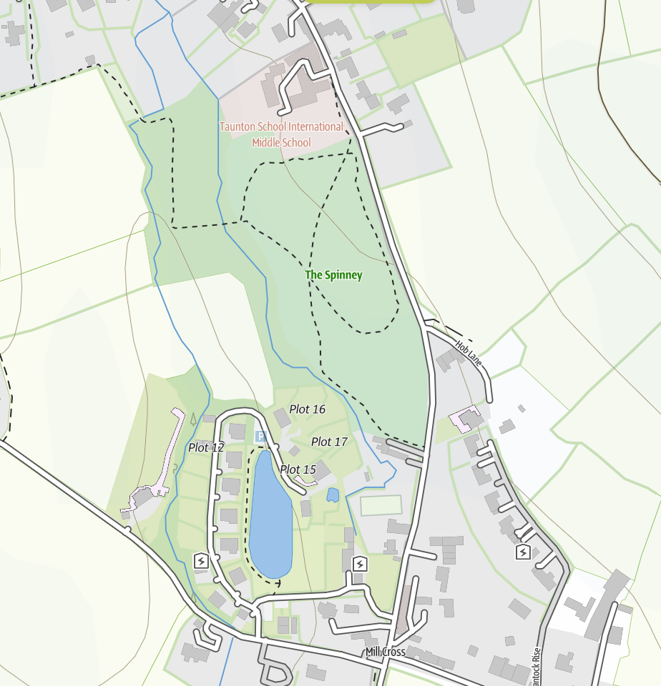

**Things to Remember to Enjoy Your Time Exploring**

* **Only use the Tramper routes on the map** – these have been audited as safe.
* **Take particular care**:
  + Near the lake & stream – Use Tortoise and turn speed dial down, keep a safe distance, check direction switch (forward/ reverse) before moving off.
  + Slope down from Spinney – Set low speed **before** going down from gate
  + Cross gradient near summerhouse – Minimise speed, only use main path by lake (not those further up the slope), turn – with extreme care – at the first lake platform.
* **Leave** **the Tramper outside** – if you want to go in a building, leave the Tramper outside (where it is not an obstruction) and take the keys with you.

In case of difficulties call: [07779 651911](https://www.google.com/search?q=mill+meadow&rlz=1C1DIEZ_enGB1012GB1012&oq=mill+meadow&gs_lcrp=EgZjaHJvbWUqDwgAECMYJxjjAhiABBiKBTIPCAAQIxgnGOMCGIAEGIoFMhIIARAuGCcYrwEYxwEYgAQYigUyDQgCEC4YrwEYxwEYgAQyDQgDEC4YrwEYxwEYgAQyBwgEEAAYgAQyBggFEEUYPDIGCAYQRRg8MgYIBxBFGDzSAQgyODExajBqN6gCALACAA&sourceid=chrome&ie=UTF-8) Enjoy exploring this beautiful area!

**In partnership with**

[This Photo](https://www.pngall.com/no-entry-symbol-png/) by Unknown Author is licensed under [CC BY-NC](https://creativecommons.org/licenses/by-nc/3.0/)

[This Photo](https://www.pngall.com/no-entry-symbol-png/) by Unknown Author is licensed under [CC BY-NC](https://creativecommons.org/licenses/by-nc/3.0/)

**Tramper Hire Guide**